**ROBOTIC ARM USING ARDUINO**

**INTRODUCTION**

#### In recent years the industry and daily routine works are found to be more attracted and implemented through automation via Robots. The pick and place robot is one of the technologies in manufacturing industries which is designed to perform pick and place operations. Literature suggests that the pick and place robots are designed, implemented in various fields such as in bottle filling industry, packing industry, used in surveillance to detect and destroy the bombs etc. The project deals with pick and place robot using arduino for any pick and place functions. The pick and place mechanical arm is a human controlled based system that detects the object, picks that object from source location and places at the desired location.

#### **WHY DID WE DECIDE TO MAKE IT?**

#### The system is so designed that it eliminates the human error and human intervention to get more precise work. There are many fields in which human intervention is difficult but the process under consideration has to be operated and controlled this leads to the area in which robots find their applications.

#### **MATERIALS (HARDWARE)**

|  |  |  |  |  |
| --- | --- | --- | --- | --- |
| **Sr. No.** | **Component Name** | **Picture** | **Description** | **Quantity used** |
| 1. | Arduino board | https://cdn.solarbotics.com/products/photos/a0266346bdc1b2028b4066554730ddfa/50450-IMG_5222.jpg | The board is equipped with sets of digital and analog input/output (I/O) pins that may be interfaced to various expansion boards (shields) and other circuits. The board features 14 Digital pins and 6 Analog pins. | 1 |
| 2. | Joystick | Related image | It is similar to two potentiometers connected together, one for the vertical movement (Y-axis) and other for the horizontal movement (X-axis). The joystick also comes with a Select switch. | 2 |
| 3. | Voltage regulator | Related image | A voltage regulator is a system designed to automatically maintain a constant voltage level. A voltage regulator may use a simple feed-forward design or may include negative feedback. It may use an electromechanical mechanism, or electronic components. | 1 |
| 4. | Breadboard | Image result for breadboard | A breadboard is a solderless device for temporary prototype with electronics and test circuit designs. Most electronic components in electronic circuits can be interconnected by inserting their leads or terminals into the holes and then making connections through wires where appropriate. | 1 |
| 5. | Battery and battery holder | https://i.ytimg.com/vi/7BYOO5u9Tz0/maxresdefault.jpg | It is electrochemical cell that transform chemical energy into electricity. It is used to provide power to circuit. | 1 each |
| 6. | Basic servo | Servo Motor | A servomotor is an electrical device which can push or rotate an object with great precision. If you want to rotate and object at some specific angles or distance, then you use servo motor. | 4 |
| 7. | Metal sheet for robotic arm |  |  |  |

Mechanical Materials

1. Metal Sheet
2. Cardboard
3. Glue gun

**MATERIALS (SOFTWARE)**

Arduino IDE: The open-source Arduino Software (IDE) makes it easy to write code and upload it to the board. It runs on Windows, Mac OS X, and Linux. The environment is written in Java and based on Processing and other open source software. This software can be used with any Arduino board.

Fritzing: Fritzing is an open-source hardware initiative that makes electronics accessible as a creative material for anyone. It is a software tool and a community website for Processing and Arduino, fostering a creative ecosystem that allows users to document their prototypes, share them with others, teach electronics in a classroom, and layout and manufacture professional PCBs.

#### **METHOD**

**STEP 1 - Connection of servo motors-**

1. Connect the brown wire from the servo to the GND pin on the Arduino.
2. Connect the red wire from the servo to the +5V pin on the Arduino.
3. Connect the orange wire from the servo to a digital pin on the Arduino.

**STEP 2 - Connection of joystick-**

1. Connect the GND pin on joystick to GND pin on the Arduino.
2. Connect the VCC pin on joystick to +5V on the Arduino.
3. Connect the VRX pin on joystick to Arduino.
4. Connect the VRY pin on joystick to Arduino.
5. Connect the SW pin on joystick to Arduino.

**STEP 3** - Install computer code in Arduino.

**STEP4** - Attach the metal sheets, battery, voltage regulator and servos.

**SCHEMATICS**

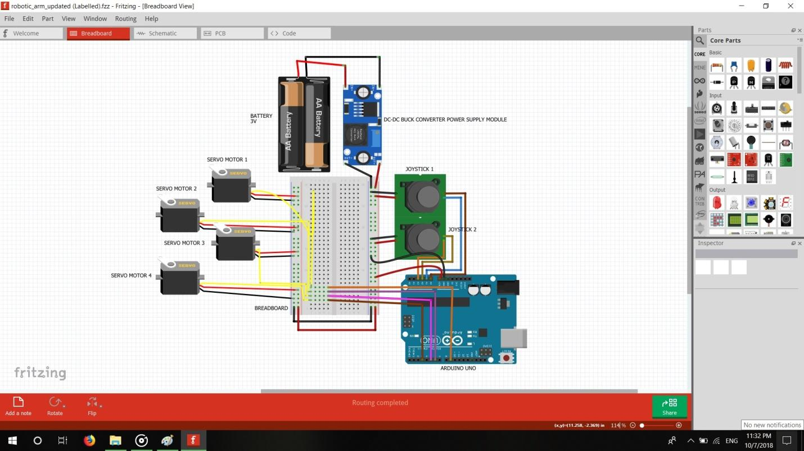

**CAD MODEL**

**Materials**

* Aluminium plates
* Holding hands
* Nuts and screws
* Joystick

**Method**

* Using nuts and screws, join holding hands and joystick to aluminium plates, which are cut in desired sizes.
* Attach this arm to a base made of aluminium plates using nuts and bolts.

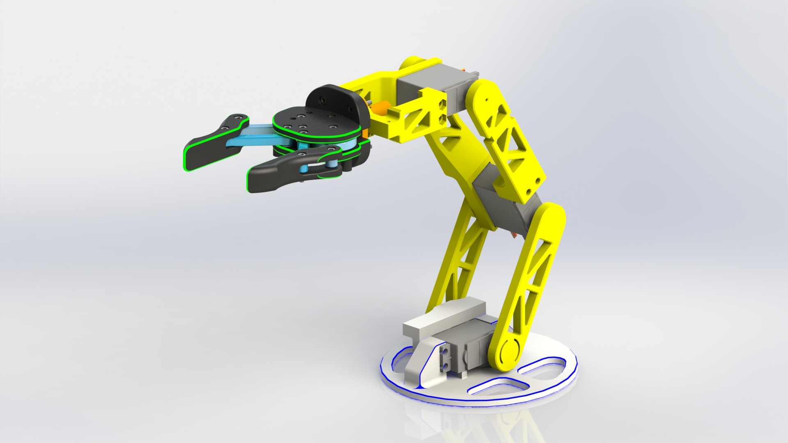

**FUTURE SCOPE**

* Easy programming and a fast average setup time makes these robot arms ideal even for small-volume productions, where rearranging large-scale facilities wouldn’t be cost-effective.
* Moving the pick and place robot to new processes is fast and easy, giving you the agility to automate almost any manual task, including those with small batches or fast change-overs. The robot is able to reuse programs for recurrent tasks.